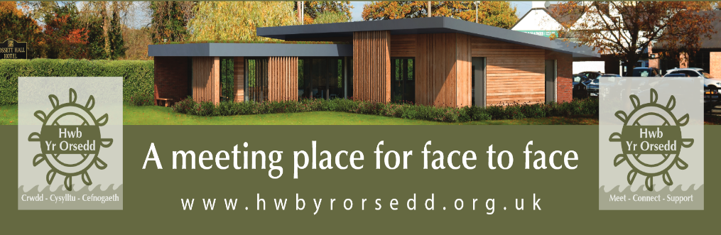

**Rossett**

**community hub**

**survey**

**Dear member of Rossett & Burton community**

As you will see, construction is progressing with the Hwb and its currently on schedule to open late summer / early autumn. Coffee, teas & snacks will be available during opening hours & it will be a great place to meet up.

So that we can maximise this valuable resource for as many members of the community as possible, we would love to hear your views and ideas for how you would like to use the community hub.

Do you belong to a group/club of approximately up to 35 people who might take advantage of this new local facility?

This is a really great opportunity to have your say as to what takes place at the HWB and when, so please do share your thoughts and ideas with us below.

1. **What age range do you fall in to? (please tick box)**

Under 18

18 – 24

25 - 34

35 - 44

45 - 54

54 - 65

65 and older

2**. When would you like to use the hub (please tick all that apply)**

Morning

Afternoon

Evenings

3. **What days of the week would you use the hub (please tick all that apply)**

Monday - Friday

Weekend

4. **What services would you like to see at the hub** **(please tick all that apply)**

Activities for young children and young people

Educational workshops & classes (eg computer skills, language learning)

Arts, crafts & cultural activities (eg painting , music lessons)

Clubs for games (eg chess, bridge, dominos, dungeons & dragons, board games)

Activities for older people

Activities for parents and children together

Social / well-being events

5. **What facilities are most important to you in our community hub (please tick all that apply)**

Co – working spaces

Library service

Meeting space for community groups

Café or social area

6. **How would you prefer to learn about events/programmes at the community hub? (please tick all that apply)**

Email newsletters

Social media (Facebook, Twitter, Instagram etc)

Local community poster boards

Essentials magazine

Word of mouth

HWB website

7. **What is currently missing in our community that our hub could provide?**

8. **Do you have any other suggestions or ideas for the community hub that this survey hasn’t covered?**

If you would you be interested in volunteering at the community hub, please email [hwbyrorsedd@gmail.com](mailto:hwbyrorsedd@gmail.com)

It is possible that the hub can be used for private hire during some evenings and if you are interested, please email [hwbyrorsedd@gmail.com](mailto:hwbyrorsedd@gmail.com) for more details.

Please complete and leave this survey at the Golden Lion / Rossett Co-op / Rossett Pharmacy by July 1st 2024

**Please Scan the QR code for an on-line version of this survey**

**For more information about the HWB please visit the website** [**https://hwbyrorsedd.co.uk/**](https://hwbyrorsedd.co.uk/)